Exp No:7 Practice Queries using ANY, ALL, IN, EXISTS, UNION, INTERSECT Set Operators.

* **ANY, ALL**
* SELECT ProductName FROM Products WHERE ProductID = ANY (SELECT ProductID FROM OrderDetails WHERE Quantity > 99);

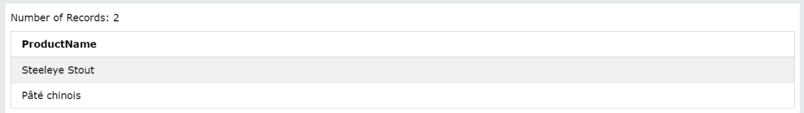

* **IN**
* SELECT * FROM Customers WHERE Country IN ('Germany');

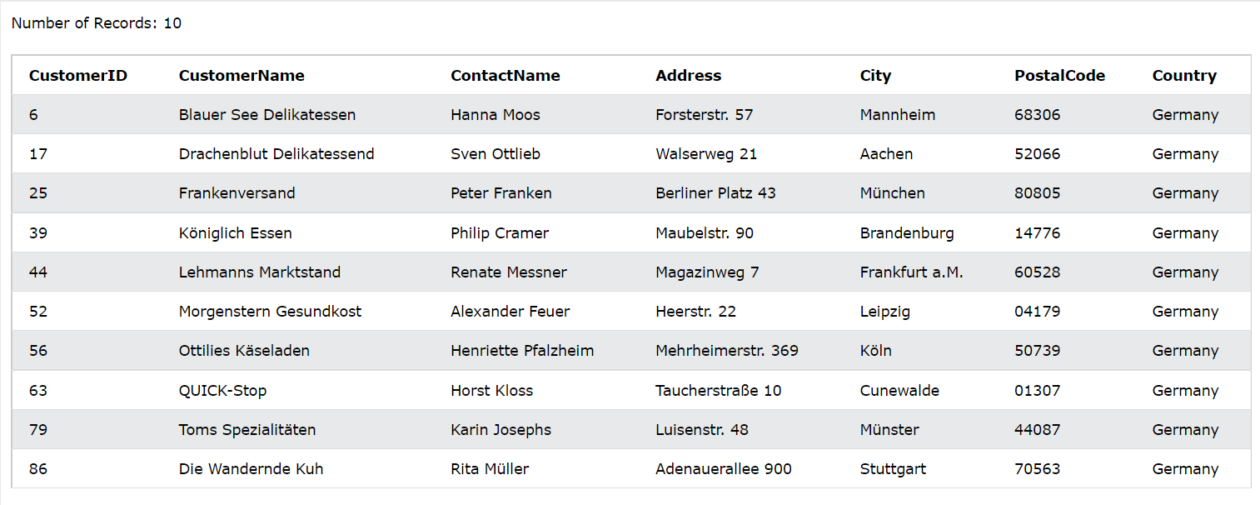

* **EXISTS**
* SELECT SupplierName FROM Suppliers WHERE EXISTS (SELECT ProductName FROM Products WHERE Products.SupplierID = 1 and CategoryID = 1);

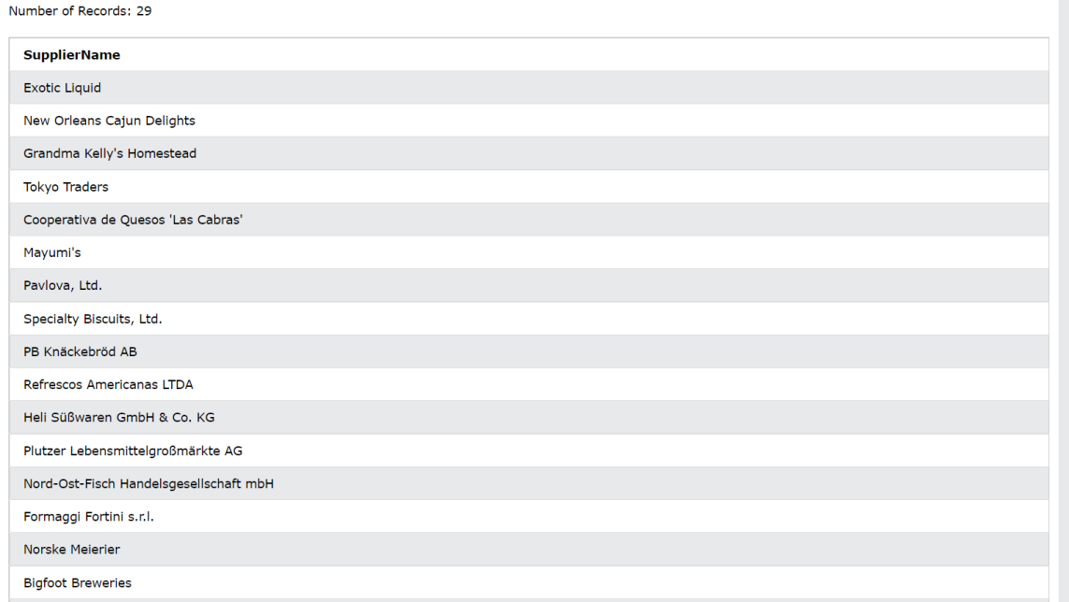

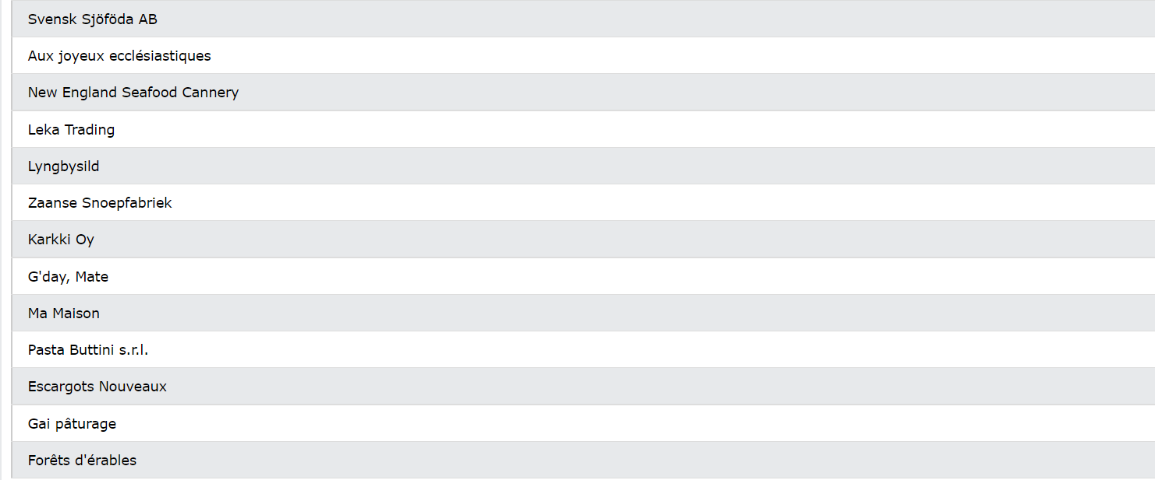

* **UNION**
* SELECT City, Country FROM Customers WHERE Country='Germany' UNION SELECT City, Country FROM Suppliers WHERE Country='Germany' ORDER BY City;

